Helping Children Cope with Emergencies
Español (Spanish)
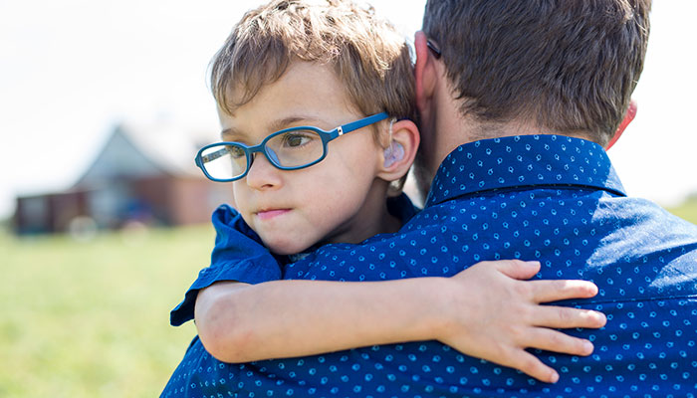
Regardless of your child’s age, he or she may feel upset or have other strong emotions after an emergency. Some children react right away, while others may show signs of difficulty much later. How a child reacts and the common signs of distress can vary according to the child’s age, previous experiences, and how the child typically copes with stress.
Children react, in part, on what they see from the adults around them. When parents and caregivers deal with a disaster calmly and confidently, they can provide the best support for their children. Parents can be more reassuring to others around them, especially children, if they are better prepared.
People can become more distressed if they see repeated images of a disaster in the media. Early on, consider limiting the amount of exposure you and your loved ones get to media coverage.

Factors that Influence the Emotional Impact on Children in Emergencies
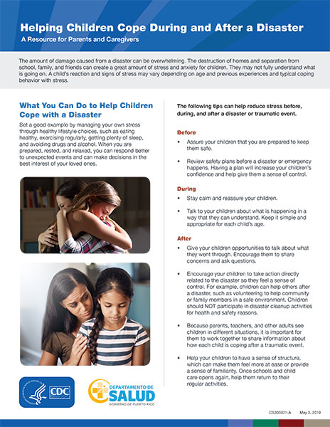
Helping Children Cope During and After a Hurricane: A Resource for Parents and Caregivers pdf icon[PDF – 822kb]
The amount of damage caused from a disaster can be overwhelming. The destruction of homes and separation from school, family, and friends can create a great amount of stress and anxiety for children.
The emotional impact of an emergency on a child depends on a child’s characteristics and experiences, the social and economic circumstances of the family and community, and the availability of local resources. Not all children respond in the same ways. Some might have more severe, longer-lasting reactions. The following specific factors may affect a child’s emotional response:
- Direct involvement with the emergency
- Previous traumatic or stressful event
- Belief that the child or a loved one may die
- Loss of a family member, close friend, or pet
- Separation from caregivers
- Physical injury
- How parents and caregivers respond
- Family resources
- Relationships and communication among family members
- Repeated exposure to mass media coverage of the emergency and aftermath
- Ongoing stress due to the change in familiar routines and living conditions
- Cultural differences
- Community resilience

What You Can Do to Help Children Cope with a Disaster
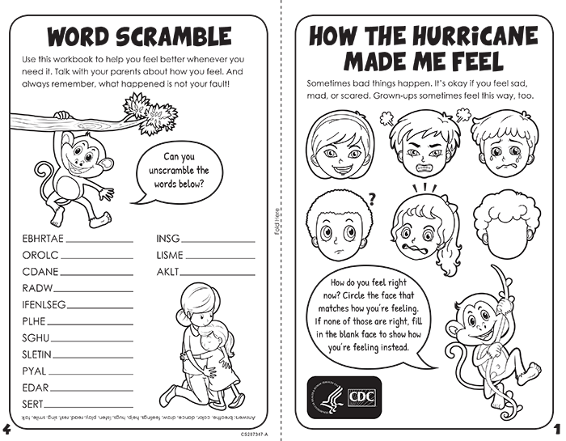
This is an activity page for younger children to learn about coping after a disaster.
Download and print the activity sheet pdf icon[PDF – 904 KB, Print]
Setting a good example for your children by managing your stress through healthy lifestyle choices, such as eating healthy, exercising regularly, getting plenty of sleep, and avoiding drugs and alcohol, is critical for parents and caregivers. When you are prepared, rested, and relaxed you can respond better to unexpected events and can make decisions in the best interest of your family and loved ones.
The following tips can help reduce stress before, during, and after a disaster or traumatic event.

Before
- Talk to your children so that they know you are prepared to keep them safe.
- Review safety plans before a disaster or emergency happens. Having a plan will increase your children’s confidence and help give them a sense of control.

During
- Stay calm and reassure your children.
- Talk to children about what is happening in a way that they can understand. Keep it simple and appropriate for each child’s age.

After
- Provide children with opportunities to talk about what they went through or what they think about it. Encourage them to share concerns and ask questions.
- You can help your children feel a sense of control and manage their feelings by encouraging them to take action directly related to the disaster. For example, children can help others after a disaster, including volunteering to help community or family members in a safe environment. Children should NOT participate in disaster cleanup activities for health and safety reasons.
- It is difficult to predict how some children will respond to disasters and traumatic events. Because parents, teachers, and other adults see children in different situations, it is important for them to work together to share information about how each child is coping after a traumatic event.

Common Reactions
The common reactions to distress will fade over time for most children. Children who were directly exposed to a disaster can become upset again; behavior related to the event may return if they see or hear reminders of what happened. If children continue to be very upset or if their reactions hurt their schoolwork or relationships then parents may want to talk to a professional or have their children talk to someone who specializes in children’s emotional needs. Learn more about common reactions to distress:

For infants to 2 year olds
Infants may become more cranky. They may cry more than usual or want to be held and cuddled more.

For 3 to 6 year olds
Preschool and kindergarten children may return to behaviors they have outgrown. For example, toileting accidents, bed-wetting, or being frightened about being separated from their parents/caregivers. They may also have tantrums or a hard time sleeping.

For 7 to 10 year olds
Older children may feel sad, mad, or afraid that the event will happen again. Peers may share false information; however, parents or caregivers can correct the misinformation. Older children may focus on details of the event and want to talk about it all the time or not want to talk about it at all. They may have trouble concentrating.

For preteens and teenagers
Some preteens and teenagers respond to trauma by acting out. This could include reckless driving, and alcohol or drug use. Others may become afraid to leave the home. They may cut back on how much time they spend with their friends. They can feel overwhelmed by their intense emotions and feel unable to talk about them. Their emotions may lead to increased arguing and even fighting with siblings, parents/caregivers or other adults.

For special needs children
Children who need continuous use of a breathing machine or are confined to a wheelchair or bed, may have stronger reactions to a threatened or actual disaster. They might have more intense distress, worry or anger than children without special needs because they have less control over day-to-day well-being than other people. The same is true for children with other physical, emotional, or intellectual limitations. Children with special needs may need extra words of reassurance, more explanations about the event, and more comfort and other positive physical contact such as hugs from loved ones.

Additional Resources

For more information about how to cope with a disaster, visit the following:
- American Red Cross: Recovering After a Disaster or Emergencyexternal icon
- Substance Abuse Mental Health Services Administration: Disaster Technical Assistance Centerexternal icon
- National Institute of Mental Health: Coping with Traumatic Eventsexternal icon
- National Child Traumatic Stress Networkexternal icon
- Emergency Preparedness and You
- Real Stories- Reunification Plans
- Practice Parameter on Disaster Preparednessexternal icon
- The Emotional Impact of Disasters on Children and Families pdf icon[6.07 MB / 43 pages]external icon
- American Academy of Pediatrics: Children & Disastersexternal icon
- Federal Emergency Management Agency: Coping with Disastersexternal icon
- Helping Children Cope During and After a Hurricane: A Resource for Parents and Caregivers pdf icon[PDF – 822kb]

