Emergency Responders: Tips for taking care of yourself
Responding to disasters is both rewarding and challenging work. Sources of stress for emergency responders may include witnessing human suffering, risk of personal harm, intense workloads, life-and-death decisions, and separation from family. Stress prevention and management is critical for responders to stay well and to continue to help in the situation. There are important steps responders should take before, during, and after an event. To take care of others, responders must be feeling well and thinking clearly.
People with preexisting mental health conditions should continue with their treatment plans during an emergency and monitor for any new symptoms. Additional information is found at the Substance Abuse and Mental Health Services Administration (SAMHSAexternal icon) website.
- Substance Abuse and Mental Health Services Administration’s (SAMHSA’s) Disaster Distress Hotline: 1-800-985-5990 or text TalkWithUs to 66746.
- People with deafness or hearing loss can use their preferred relay service to call 1-800-985-5990.
See the SAMHSA tip sheet, Tips for Disaster Responders: Preventing and Managing Stressexternal icon
Here are some important steps responders can take to ensure they are able to do their job and cope with challenging situations:

Preparing for a Response:
- Try to learn as much as possible about what your role would be in a response.
- If you will be traveling or working long hours during a response, explain this to loved ones who may want to contact you. Come up with ways you may be able to communicate with them. Keep their expectations realistic, and take the pressure off yourself.
- Talk to your supervisor and establish a plan for who will fill any urgent ongoing work duties unrelated to the disaster while you are engaged in the response.
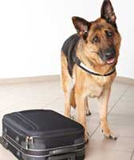
Make plans for your household, childcare, and pet care needs if you will be away from home.

During a Response: Understand and Identify Burnout and Secondary Traumatic Stress
Limit your time working alone by trying to work in teams.
Responders experience stress during a crisis. When stress builds up it can cause:
- Burnout – feelings of extreme exhaustion and being overwhelmed.
- Secondary traumatic stress – stress reactions and symptoms resulting from exposure to another individual’s traumatic experiences, rather than from exposure directly to a traumatic event.
Coping techniques like taking breaks, eating healthy foods, exercising, and using the buddy system can help prevent and reduce burnout and secondary traumatic stress. Recognize the signs of both of these conditions in yourself and other responders to be sure those who need a break or need help can address these needs.

  - Signs Of Burnout:
  - Sadness, depression, or apathy
  - Easily frustrated
  - Blaming of others, irritability
  - Lacking feelings, indifferent
  - Isolation or disconnection from others
  - Poor self-care (hygiene)
  - Tired, exhausted or overwhelmed
  - Feeling like:
    - A failure
    - Nothing you can do will help
    - You are not doing your job well
    - You need alcohol/other drugs to cope
- Signs of Secondary Traumatic Stress
- Excessively worry or fear about something bad happening
- Easily startled, or “on guard” all of the time
- Physical signs of stress (e.g. racing heart)
- Nightmares or recurrent thoughts about the traumatic situation
- The feeling that others’ trauma is yours
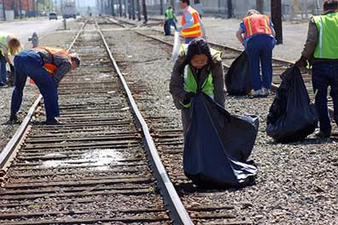
Limit your time working alone by trying to work in teams.

Get support from team members: Develop a Buddy System
In a buddy system, two responders partner together to support each other, and monitor each other’s stress, workload, and safety.
- Get to know each other. Talk about background, interests, hobbies, and family. Identify each other’s strengths and weaknesses.
- Keep an eye on each other. Try to work in the same location if you can.
- Set up times to check-in with each other. Listen carefully and share experiences and feelings. Acknowledge tough situations and recognize accomplishments, even small ones.
- Offer to help with basic needs such as sharing supplies and transportation.
- Monitor each other’s workloads. Encourage each other to take breaks. Share opportunities for stress relief (rest, routine sleep, exercise, and deep breathing).
- Communicate your buddy’s basic needs and limits to leadership – make your buddy feel “safe” to speak up.
Read morepdf icon about the buddy system.

Responder Self-Care Techniques
- Limit working hours to no longer than 12-hour shifts.
- Work in teams and limit amount of time working alone.
- Write in a journal.
- Talk to family, friends, supervisors, and teammates about your feelings and experiences.
- Practice breathing and relaxation techniques.
- Maintain a healthy diet and get adequate sleep and exercise.
- Know that it is okay to draw boundaries and say “no.”
- Avoid or limit caffeine and use of alcohol.
It is important to remind yourself:
- It is not selfish to take breaks.
- The needs of survivors are not more important than your own needs and well-being.
- Working all of the time does not mean you will make your best contribution.
- There are other people who can help in the response.
Responding to disasters can be both rewarding and stressful. Knowing that you have stress and coping with it as you respond will help you stay well, and this will allow you to keep helping those who are affected.
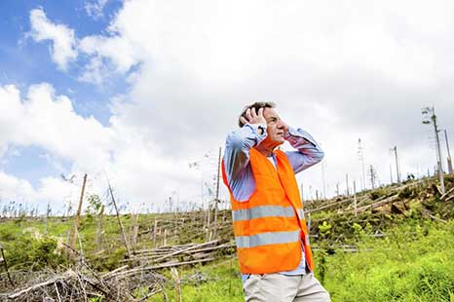
Responders will experience stress. Managing stress and taking breaks will make you a better responder.

After the response: Family and Work-life
These are some resources responders can share with their family members and co-workers:

  - Adjusting to life at home: Tips for Families of Returning Disaster Respondersexternal icon
  - Tips for Disaster Responders: Returning to Workexternal icon
Family members can help make the transition easier after the response is over.

Additional Resources:
- Traumatic Incident Stress (CDC National Institute for Occupational Safety and Health- NIOSH)
- Interim NIOSH Training for Emergency Responders: Reducing Risks Associated with Long Work Hours (CDC NIOSH)
- Resilience Resources for Emergency Responseexternal icon (Occupational Safety and Health Administration)
- Psychological First Aid for First Respondersexternal icon (SAMHSA)
- Guidelines for Good Practice: Managing Stress in Humanitarian Workerspdf iconexternal icon (Antares Foundation)
- Guidance for Emergency Responders in U.S. Virgin Islands and Puerto Rico

